# Homework: Semantic HTML, Frames, Other Tags

This document defines homework assignments from the [“Web Fundamentals (HTML & CSS)“ Course @ SoftUni](https://softuni.bg/courses/web-fundamentals/). Please submit as homework a single zip / 7z archive holding the source code of all below described problems.

## Refactor HTML

Refactor the 01-Refactor-Webpage.html web page and make its HTML Semantic. **Do not apply styles**.

## Kent’s Media Profile

Create a HTML page like the image below (100% accuracy is not required). **Use meter, figure, figcaption, audio, video, embed, source, track tags.**



## Magic Car Gallery

Create a HTML page like the image below. Make sure that the whole webpage doesn’t reload every time the user clicks on a link to change the image shown in the box. **Use iframe tag.**

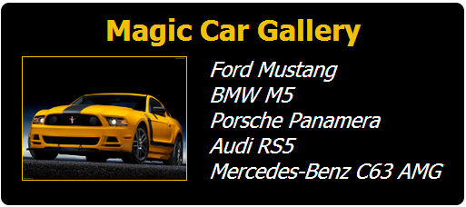

## BGJUG WebPage

Create two HTML page like the image below (100% accuracy is not required). **Use frames for the layout of the first one. Use semantic tags and tables for the layout of the second one.**



## *JavaScript Worship

Create a HTML page like the image below. Use canvas and JavaScript. **100% accuracy IS required.**



## **Barbie’s Twitter

Create a web page like the image below (**100% accuracy is preferable**) and make its HTML Semantic. **Use some kind of approach to support old (non-HTML5-compatible) Web browsers like IE6-IE8.**

